Coordinates for Blue Hill Escape:

-33° 35' 31.4268", 23° 24' 22.5036" or -33.592063, 23.406251

Driving instructions to Blue Hill Escape:

- Travelling on the N9 between Uniondale and Willowmore:
- 11 km north of Uniondale (48 km south of Willowmore) turn east onto gravel road at sign “Hartbeesrivier”.
- Drive for 18.8 km to Hartbeesrivier (a cluster of houses).
- At the Y-junction follow the main road left.
- Drive for 6 km. Turn right onto a small gravel road. (Signed: "Paardekraal"; Blue Hill Nature Reserve). You still have 4.6 km to go.
- Drive past several buildings and through two gates. Please leave gates open or closed as you find them.
- Y-junction: turn left. (Sign: "Paardekraal"; Blue Hill Nature Reserve); cross a small stream.
- Third gate.
- Drive up to the house.

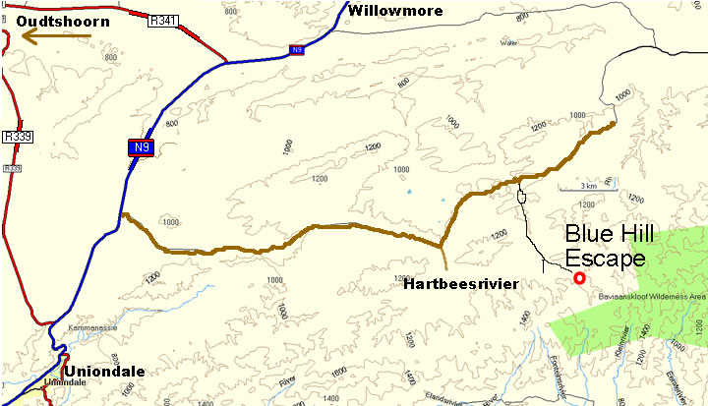

From Willowmore – alternative route (although shorter, a longer extent is gravel and so driving times are equivalent or even longer on this route)

- Travelling on the N9 between Willowmore and Uniondale:
- About 3 km south of Willowmore turn left onto gravel road towards Baviaanskloof.
- Drive for 29 km. Turn right towards Uniondale.
- Stay on this road for 27.3 km. Ignore the Uniondale turn-off to the right after 14.3 km and continue straight towards Hartbeesrivier.
- After 27.3 km turn left onto a smaller gravel road (signs “Paardekraal” and “Blue Hill Escape”). You still have 4.6 km to go.
- Drive past several buildings and through two gates. Please leave gates open or closed as you find them.
- Y-junction: turn left. (Sign: "Paardekraal"; Blue Hill Nature Reserve); cross a small stream.
- Third gate.
- Drive up to the house.

kmaaand km. Rest see directions from Willowmore.

