Coordinates for Blue Hill Escape:

S33 35.5’
E23 24.4’

Driving instructions to Blue Hill Escape:

- Travelling on the N9 between Uniondale and Willowmore:
- 11 km north of Uniondale (48 km south of Willowmore – for a more scenic route from Willowmore see instructions on second page) turn east onto gravel road at sign “Hartbeesrivier”.
- Drive for 18.8 km to Hartbeesrivier (cluster of houses).
- At the Y-junction follow the main road left.
- Drive for 6 km. Turn right onto a small gravel road. (Sign: "Paardekraal"). You still have 4.6 km to go.
- At next Y-junction turn left if you have a 4x4 or right if not. Roads meet shortly after.
- Drive past several buildings and through two gates.
- Y-junction: turn left. (Sign: "Paardekraal").
- Third gate: our property. Drive up to the house.

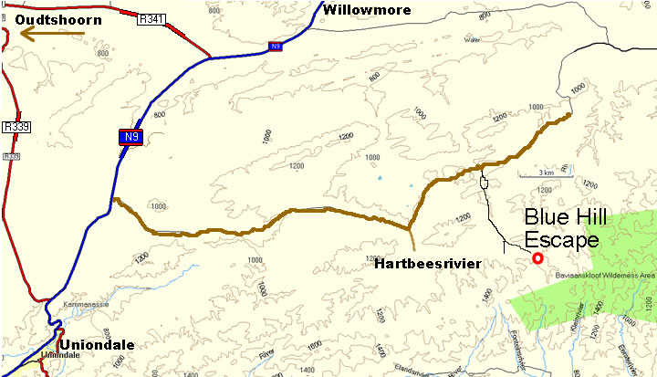

From Willowmore – alternative route (although shorter, a longer extent is gravel and so driving times are equivalent or even longer on this route)

- Travelling on the N9 between Willowmore and Uniondale:
- About 3 km south of Willowmore turn left onto gravel road towards Baviaanskloof.
- Drive for 29 km. Turn right towards Uniondale.
- Stay on this road for 27.3 km. Ignore the Uniondale turn-off to the right after 14.3 km and continue straight towards Hartbeesrivier.
- After 27.3 km turn left onto a smaller gravel road (signs “Paardekraal” and “Blue Hill Escape”). You still have 4.6 km to go.
- At next Y-junction turn left if you have a 4x4 or right if not. Roads meet shortly after.
- Drive past several buildings and through two gates.
- Y-junction: turn left. (Signs: "Paardekraal" and “Blue Hill Escape”).
- Third gate: our property. Drive up to the house.

