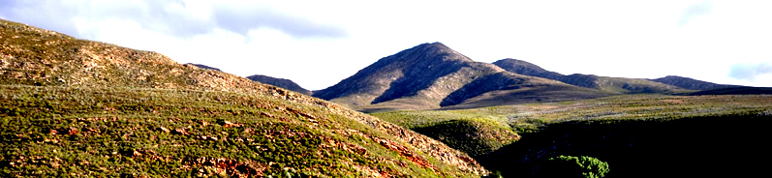
Blue Hill Escape - Guest House and Mountain Fynbos Reserve

P.O. Box 131 - Uniondale 6460 - Phone: +27 (0)44 752 1254 - www.bluehillescape.co.za - info@bluehillescape.co.za

Terms and Conditions

The rental contract begins with receipt of a booking confirmation and payment of a 50 % deposit.

The balance is payable in cash on arrival. There are no credit card facilities.

Full refund for cancellations up to 14 days prior to date of arrival. An administration fee may apply.

The number of people staying may not exceed the number of people booked for.

Your booking confirmation / invoice confirms which room(s) you have booked. You are not entitled to a different room if the room you have booked is in good order.

Check-in: 14:00 – 20:00; Check-out: 10:00. Unless otherwise agreed.

Blue Hill Escape cannot be held responsible for any items lost on the property. A safe is available at reception.

A key-loss charge of R100 applies.

A first aid kit is available on request.

All items borrowed from Blue Hill Escape must be returned prior to departure. This includes maps, any sort of equipment, books, etc.

Your stay at Blue Hill Escape Nature Reserve, including all activities, the use of the trail system, etc. is entirely at your own risk.

It is your responsibility to ensure that you have all the information and equipment needed for your activity, and that you wear appropriate clothing. Read our guest information folder and speak to Blue Hill Escape staff if you have questions.

Blue Hill Escape does not assume responsibility for damages to any kind of vehicle used on the property, or for injuries to persons on the property.

Parents are responsible for their children.

Dogs must be kept on a leash. The owner will be held responsible for any damages caused to domestic animals, wildlife, plants or people.

The feeding or intentional disturbance of wildlife is a serious offence.

Windows and doors of ground-floor accommodation must be closed when going out to avoid a baboon raid.

No plants, animals, wildlife or any natural or cultural items may be removed from the property without permission.

Fires are only allowed in designated areas.

No smoking anywhere indoors. Cigarette butts must be extinguished and disposed of properly. They are a fire-hazard and look ugly.

Littering is prohibited. All litter must be disposed of in the bins provided.

No off-road driving. Vehicles must remain on the designated roads at all times.

