Vegetation of the BLUE HILL Nature Reserve.

The proposed Blue Hill Nature Reserve (Paarde Kraal 84, Uniondale) borders on the western side of the Baviaanskloof Provincial Nature Reserve and contains four vegetation variants (Vlok et al. 2005).
The water drainage lines are dominated by the Tsitsikamma perennial stream vegetation variant, the higher altitude areas are dominated by Kouga Mesic Proteoid Fynbos and Kouga Grassy Fynbos and parts of the lower lying areas to the east of the Blue Hill Nature Reserve are dominated by the Hartbeesvlakte Sandolien Renosterveld vegetation variant (Figure 1). More detailed descriptions of the broader habitat units (Sandolienveld, Grassy Fynbos and Mesic Proteoid Fynbos) and the specific vegetation variants of these habitat units that occur on the property are described below.

Dr A.D. Wheeler
CapeNature
Oudtshoorn
044 2036300
3 June 2010

Sandolienveld

This habitat forms a distinct band in the lowlands where Fynbos and Renosterveld meet the Succulent Karoo and Thicket biomes. It is easy to recognize as the tall shrub Sandolien (Dodonaea angustifolia) is always abundant here. Depending on local soil conditions and rainfall, it may have Fynbos, Renosterveld, Succulent Karoo or Thicket elements present and sometimes even a mix of species from all these biomes.

In wetter sandy sites one usually finds Fynbos elements present (including some Restios), with Renosterbos (Elytropappus rhinocerotis) often abundant amongst the Sandolien where the soils are more clayey. The Thicket and Succulent Karoo elements occur mostly in rocky and arid areas where they are protected against periodic fires. Succulents (including Aloe comptonii, Aloe ferox, Aloe microstigma, etc.) and some woody trees (e.g. Euclea undulata, Maytenus oleoides, Pterocelastrus tricuspidatus and Rhus undulata) may thus be present on north-facing slopes and rocky outcrops. A variety of other shrubs (Agathosma, Felicia, Lobostemon, Montinia, Passerina, Phylica, Polygala, etc.) and grasses (Aristida, Cymbopogon, Pentaschistis, Themeda, etc.) are usually present.

Sandolienveld is in general quite an arid habitat, especially during summer, when fire occasionally occurs here. It seems to have a low fire frequency, but when it does burn it burns at very high fire intensities. Sandolien is one of the first shrubs to recover after fire, as it is able to resprout. Recruitment by means of seedlings is not restricted to the post-fire environment as seedlings also occur in unburned sites where the vegetation has been opened by physical disturbance. Some of the short-lived species that appear after fire (e.g. Lotononis spp.) is endemic to this habitat, but not many localized endemic species are known from this habitat.

Although Sandolienveld has a wide variety of plant growth forms present it varies little in the species present over most of its distribution range. The many different Fynbos, Renosterveld, Succulent Karoo and Thicket vegetation units with which Sandolienveld forms mosaic vegetation types introduce variance in species that one finds here, so much so, that 21 vegetation units are recognized to occur in this habitat.

The basic Sandolienveld component of species seems to consists of a very rigid coalition of species supported in the eastern Little Karoo by some summer rain and certain soil conditions (often relating to the old African surface), this coalition disintegrates gradually westwards, where Fynbos or Renosterveld units replace it. One of the components that are favored by summer drought and an increase of winter rain are tall, drought-tolerant Restios (e.g. Rhodocoma arida, Thamnochortus karooica, etc.). Here the Sandolienveld habitat changes into the Arid Restioid Fynbos habitat.

The Hartbeesvlakte Sandolien-Renosterveld is similar to the Leeublad Sandolien-Renosterveld in having Renosterbos (Elytropappus rhinocerotis) dominant on the north facing slopes and Sandolien (Dodonaea angustifolia) more prominent on the south facing slopes often with some Fynbos elements (e.g. Calopsis andraeana, Ischyrolepis capensis, Montinia caryophyllacea, Oedera squarrosa, Passerina obtusifolia, Phylica axillaris, Rhodocoma fruticosa, Thamnochortus rigidus, etc.) present. It is, however, a more arid unit with succulents (e.g. Aloe comptonii, Aloe ferox, Machairophyllum acuminatum, etc) more prominent, along with some trees (e.g. Euclea undulata, Rhus undulata, etc.), on north facing slopes. Romulea jugicola is the only rare species known from this unit.

Grassy Fynbos

The Grassy Fynbos habitat type is also easy to recognize, as it is structurally very simple, with grasses (mostly only C3-grasses such as Aristida, Merxmuellera, Pentameris, Pentaschistis, etc.) abundant. Restios (Calopsis, Hypodiscus, Ischyrolepis, Restio, Rhodocoma, etc.) and Ericas are present, but never prominent. Proteas (mostly only Leucospermum and Paranomus) are rare, but quite a variety of other shrubs (Agathosma, Aspalathus, Euryops, Eriocephalus, Felicia, Heliophila, Hermannia, Montinia, Passerina, Phylica, etc.) may be present. Some short-lived shrubs (Aspalathus and Hermannia) may be super-abundant after a fire, when some geophytes are also present, but the geophytes are never as abundant as they tend to be in the wetter Fynbos habitats. Despite the relative abundance of grasses the Grassy Fynbos is not particularly suitable for grazing purposes, except perhaps for bulk-grazers, e.g. Mountain Zebra.

The Kouga Grassy Fynbos is also characterized by having Merxmuellera arundinacea dominant on north facing slopes with few Proteas and Ericas on these north facing slopes, in this unit Protea nitida and shrubs such as Erica cerinthoides, Erica simulans, Leucadendron salignum and Leucospermum cuneiforme are occasionally prominent in small patches on south facing slopes. It shares most of its common species with the Grassy Fynbos of the more western areas (e.g. Heliophila glauca, Osteospermum imbricatum), but some of the species present in the Kouga Grassy Fynbos (e.g. Agathosma puberula and Muraltia juniperifolia) are absent from all the other Grassy Fynbos units of the Little Karoo domain. It also differs from most of the other Grassy Fynbos units in often having sweet grasses (C4 species such as Themeda triandra) quite abundant after fire.

Mesic Proteoid Fynbos

The Mesic Proteoid Fynbos differs mostly from the Arid Proteoid Fynbos in its structure, with the proteoid shrubs often so dense that they form a closed canopy, the ericoid shrubs (especially Erica species) tend to be more abundant and the sedge (Cyperaceae) component is often better developed than in Arid Proteoid Fynbos. The species present are the best indicators with Leucadendron eucalyptifolium (as opposed to Leucadendron rubrum in the Arid version), Leucadendron spissifolium (as opposed to Leucadendron salignum in the Arid version), Protea neriifolia and Protea punctata (as opposed to Protea laurifolia, Protea lorifolia and Protea repens in the Arid version) are reliable indicators. The same holds for the Restios with for instance Cannamois virgata often abundant here (Cannomois scirpoides in the Arid version) and in the Ericas with Erica copiosa present (as opposed to Erica melanthera in the Arid version). The plant communities present in the Mesic Proteoid Fynbos differs so much on the different mountains of the region, that 19 vegetation units are recognized in this habitat type.

The Kouga Mesic Proteoid Fynbos is most similar to the Kamanassie Mesic Proteoid Fynbos as Leucadendron eucalyptifolium, Protea eximia, Protea punctata and Protea neriifolia are also abundant to locally dominant in this unit, but it differs in its rare and local endemic component. Here the following species are present; Agathosma spinosa, Erica kougabergensis, Erica saptouensis, Cyclopia plicata, Leucadendron sorocephalodes and in rocky outcrops, Encephalartos longifolius and Widdringtonia schwarzii.

Freshwater stream and seepage habitat

The Freshwater stream and seepage habitat type differs from the River and floodplain habitat type in having only fresh water flowing through these units. This difference in water regimes resulted in quite a different kind of vegetation being present as at least some subsurface freshwater is permanently available. Most of this habitat type is restricted to areas located within or to the base of the Cape sandstone mountains and their soils are usually sandy and acidic. Where they do occur on shale, the floor of the streambed is often lined with rounded white sandstone pebbles.

In the upper catchment areas the habitat starts as perennial or seasonal water seepage zones, here the vegetation is often short and dominated by restioid and/or graminoid vegetation. On the lower mid-slopes woody shrubs become more prominent, especially once several streams have joined up to form a prominent water drainage channel. Typical and characteristic of these perennial streams are an abundance of shrubs such as Empleurum unicapsulare, Psoralea affinis, Psoralea imminens and Psoralea nubicola and broad-leaved herbs such as Gunnera perpensa. The vegetation along these streams is usually dense and almost impenetrable when old.

Lower in the landscape, where the drainage channel changes from quartzitic to shale substrates, the composition of the vegetation changes rapidly. From this point onwards the habitat is in most cases changed to the Riverine and floodplain habitat type. There are some exceptions, such as in Seweweekspoort, Meiringspoort and Schoemanspoort where high volumes of fresh water retain the vegetation similar to those of the upper streams. These exceptions are usually easy to recognize as the streambed is lined with white sandstone pebbles and boulders. These rivers could be recognized as a habitat type of their own, but are here included in the stream and seepage habitat type. Flood resistant trees and shrubs are abundant in these lower freshwater rivers and streams with Cliffortia strobilifera, Freylinia lanceolata, Rhus laevigata and Salix mucronata the most common species. Remnant populations of these species can be found even in cases where the water supply of these streams has been cut off for many years. They and other typical herbs and graminoids, such as Carpha glomerata, Juncus effuses, Juncus oxycarpus and Zanthedeschia aethiopica, have been used as indicators of streams that have (or had) a perennial supply of fresh water.

This unit is an important habitat for flora and fauna. Especially the mid- to upper sections of this habitat is often rich in highly localized endemic plant species. Some localized endemic vertebrates and invertebrates (e.g. Heleophryne spp.) are also present. It is also the favored habitat for some rare bird species (e.g. Victorin’s Warbler). This habitat is obviously vital for humans, as it delivers clean fresh water to agriculture and communities at the base of mountains. Once this vegetation is disturbed it results in accelerated soil erosion (reduction in water quality), invasion by alien species (increased water use by stream bank vegetation) and loss of biodiversity (specialized organisims restricted to this habitat). When it is in a pristine condition it is remarkably resilient to invasion by alien plant species. Rubus and Populus species seem to be the only plants able to invade undisturbed examples of this habitat.

This habitat is severely threatened by the abstraction of groundwater as altered water availability results in the rapid demise of this habitat. Certain species that have a very narrow habitat that is restricted to just above the summer water flow level, such as Disa elegans, Disa tripetaloides, Disa uncinata, Gladiolus aquamontanus and Osmunda regalis, are even vulnerable to altered seasonal water flow regimes. Some of the rare shrubs restricted to this habitat, like Erica astroites, Penaea dahlgrenii, Stirtonanthus chrysanthus and Stirtonanthus taylorianus may be less vulnerable to the actual volume of water flowing in the stream but they would certainly die rapidly if no water were available.

The Tsitsikamma perennial stream unit is most similar to the Keurbooms River & perennial stream unit, but here the streams drain northwards into the Olifants River system. Afro-montane forest patches are absent here and the unit is dominated by fynbos species such as Cannomois virgata, Leucadendron conicum, Leucadendron eucalyptifolium, Platycaulos compressus, Protea neriifolia and Protea mundii, often with Pteronia camphorata abundant. Uncommon species present are Leucadendron uliginosum ssp. glabratum, with rare species present including an odd locality for Disa marlothii and another unusual orchid Pterygodium newdigateae not uncommon after fire on the upper streambank.
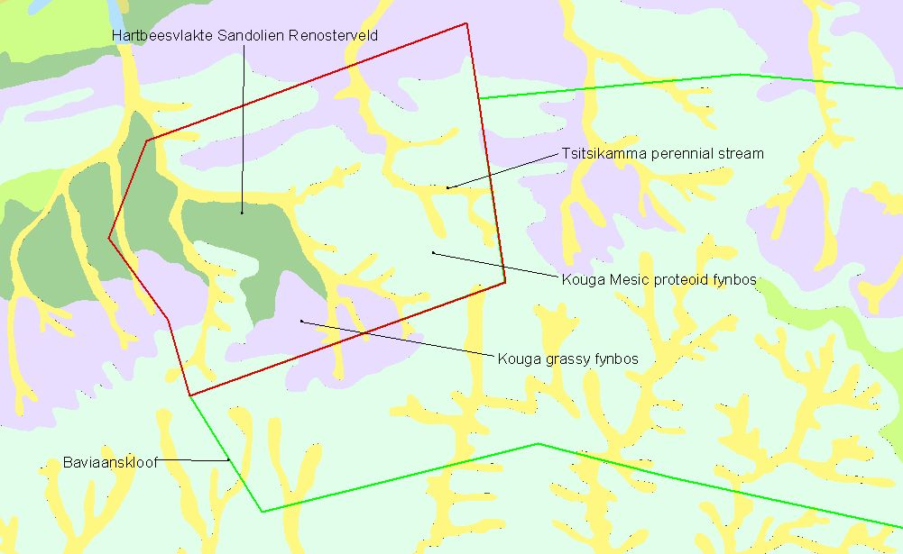

Figure 1. Vegetation variants of the Blue Hill Nature Reserve (Vlok et al. 2005).

